MYSQL Practical 1

- Open your browser at the following URL http://mysql05.comp.dkit.ie/phpmyadmin/
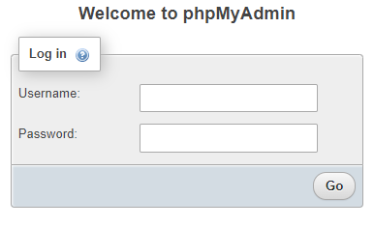
- Use you student number and the password supplied in the ‘root’ email, to log into your mysql account

- When successfully logged in, the phpMyAdmin interface below should be displayed
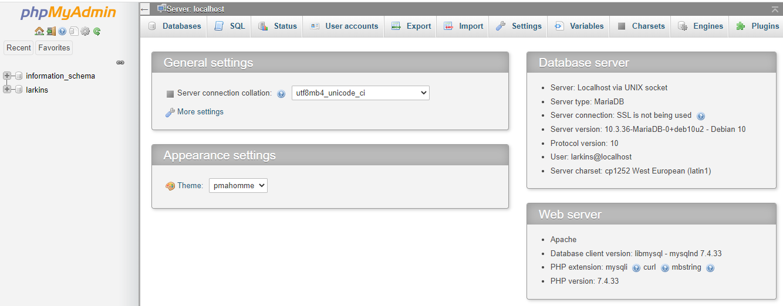

- A default database with your student number is already created
- Open the database by clicking on your student number in the left hand panel

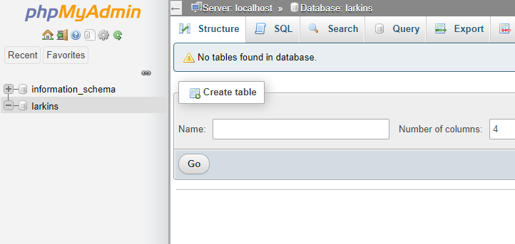

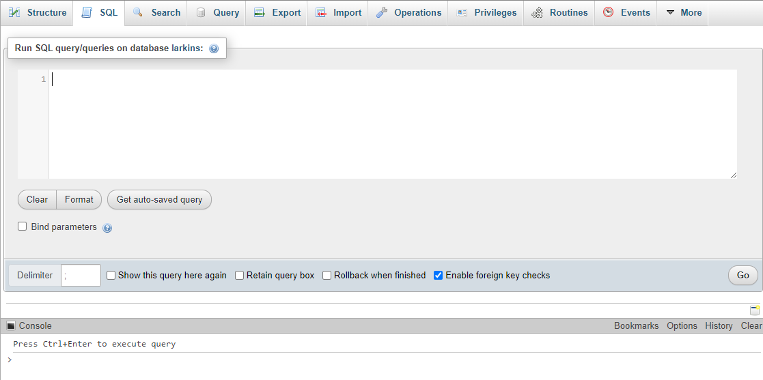
- Click on the SQL tab to open the editor

In the SQL Editor you can enter SQL commands to create tables and insert data into those tables etc.
SQL Commands:
create table …
insert into …
MySQL Server
Database Tables

Try the following commands:
Use Notepad++ to create the commands in an SQL file
Copy the commands to the SQL editor in phpMyAdmin

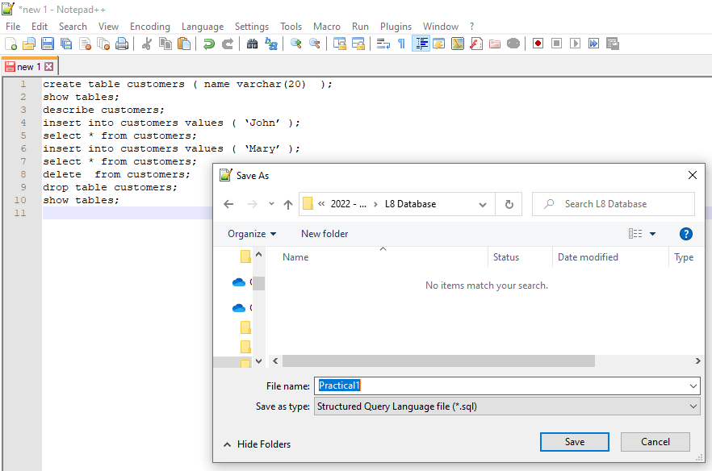

create table customers ( name varchar(20) );
- creates a very simple table with one column of type varchar.
- You can look up data types on the MySql documentation website

show tables; - shows the tables in the database
describe customers; - gives details about the customers table structure
insert into customers values ( ‘John’ ); - adds a row to the table
select * from customers; - show ALL (*) the rows of data
insert into customers values ( ‘Mary’ ); - adds a row to the table
select * from customers; - show ALL (*) the rows of data
delete from customers; - deletes ALL rows from table (be careful!)
drop table customers; - deletes the whole table
show tables; - the customers table should no longer be present
Exercise:

Recreate the customer table with three fields:
create table customers ( firstname VARCHAR(20), surname VARCHAR(20), address VARCHAR(20));

Populate it with the records from the flat file database notes

insert into customers values(‘Joe’, ‘Murphy’, ‘Dundalk’);

insert into customers values(‘Ann’, ‘Glynn’, ‘Ardee’);
etc……

Try the following commands:
select * from customers; - show ALL (*) the rows of data
select firstname, surname from customers; - show firstname and surname for all rows of data
select address from customers; - show address for all rows of data
select distinct address from customers; - show only distinct addresses for all rows of data

To return results that match a criteria use the where clause with the select statement

Try the following commands:
select * from customers where firstname = ‘Joe’;
select firstname, surname from customers where address = ‘Dundalk’;

AND Operator
select * from customers where firstname = ‘Vera’ and surname = ‘Nolan’;

OR Operator
select * from customers where firstname = ‘Joe’ or firstname = ‘Ann’;

Wildcards
select firstname, surname from customers where address like ‘D%’;
select firstname, surname, address from customers where firstname like ‘A%’ or address like ‘%o%’;

Extra Work

Try commands to do the following

All details for customers who live in Ardee
All details for customers with first name Harry or surname White
First name and Surname for customers who live in Blackrock
First name and Surname for customers with an address that begins with D
All details for customers with surname that begins with G and live in Ardee
Address for Tim Woolworth

